Software 2

Coffee Machine

**Team members:**

1. Kerolos Emad 42016045
2. Enas Alaa 42016017
3. Makarios Nassef 42016059
4. Manar Abd elHamid 42016060
5. Mostafa Salah Eldin 42016057

TA/ Mona Mohammed

**Requirements Specification**

**Functional Requirements:**

**1) Order Coffee:**

-1.1 the user shall enter the payment method

-1.2 after that he selects his coffee

-1.3 the system shows the coffee cost and asks the users to confirm the order

-1.4 if the user approved the system is going to ask him to place empty cup below the filter

-1.5 when the order is done a reset of the cost is the output of this function

**2) Making Coffee:**

-2.1 The user shall get empty cup placed right below the filter.

-2.2 The user shall be able to choose his preferred beverage from the list of options (buttons).

-2.3 There must be buttons (start, pause, stop, coffee, tea, milk) for user to interact with the system.

-2.4 The user shall be able to purchase one kind of available drink at a time and get back the exact changes if he has put extra money.

-2.5 The user shall be able to quit the dispense of any beverage at any time during the dispensing

**3) Adding extras:**

-3.1 the customer asks the machine for adding extras on his order by selecting adding extra option.

-3.2 the machine shows a list of the possible extras that he may select.

-3.3 The machines approve his selection and add extras.

**4) Select Item:**

-4.1 The machines provide customer with some customizable items.

-4.2 The customer can choose his item to be processed by the machine.

-4.3 The customer shall be able to make some operations as:

Choose item: Users select an item from the list of items.

**5) Sell Item:**

Sell item: After choosing his item, user could buy his chosen item.

**6) Cancel Item:**

Cancel item: If any something wrong happened, user could easily cancel his request & request another one.

**7) Add Item:**

Also the customer could use other operations to facilitate his order as: Add item: Customer shall be able to add item from the list of items.

**8) Edit Item:**

Edit item: He could also modify his order by editing his chosen item.

**9) Delete Item:**

Delete item: If the chosen item doesn’t meet his need, so he could delete it.

**10) Check Payment:**

After choosing his items & making his order, customer shall be able to check his payment for depositing.

**11) Payment Refund:**

The system shall refund the payments if in need by the user before the item gets ready for dispense

**Nonfunctional requirements:**

**Safety**: The machine will turn off if the heating system is used for more than 2 hours.

The Coffee Maker system shall provide a status indicator light on the Console for Power (ON/OFF).

**Performance:** The power source shall provide more than 110 volt AC.

The coffee basket shall be removed and cleaned.

The Coffee Maker system shall provide two modes for activating the brew cycle: (a) manual, and (b) automatic. The automatic mode shall be controlled by a time mechanism that permits the Coffee User to specify the time of day in Hours/Minutes AM/PM at which the brew cycle shall be activated (when the Power is ON).

**Usability:** The control console shall be easy to read for coffee machine user.

**Context model:**

A close up of text on a white background

Description generated with high confidence

**Object-Class:**

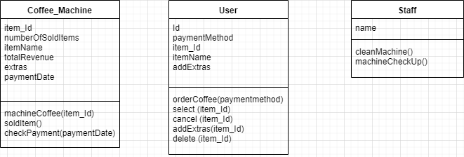

**Use cases:**

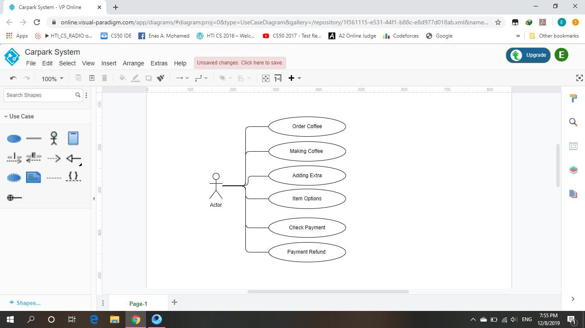

**System:** Coffee machine

**Use case:** Order Coffee.

**Actor:** User

**Data:** The user will enter the payment method then he should selects his coffee after that the system shows the coffee cost and then the machine asks the users to confirm the order. If the user approved, the system is going to ask him to place empty cup below the filter. When the order is done a reset of the cost is will be ready to pull it.

**Stimulus:** Orders the coffee, shows the customer how much it. If he confirms the order, the system will do it and the reset of the cost is come out.

**Response:** The machine accepts payments and show up the items.

**Comments:** The card should be valid for operation.

**Use case:** Making Coffee.

**Actor:** User

**Data:** The user get empty cup placed right below the filter, Be able to choose his preferred beverage from the list of options (buttons) and quit the dispense of any beverage at any time during the dispensing.

**Stimulus:** Make the coffee, shows the customer available options to choose his preferred beverage.

**Response:** Machine takes the order and work on preparing it.

**Comments:**

**Use case:** Adding extras.

**Actor:** User

**Data:** The customer asks the machine for adding extras on his order by selecting adding extra option, the machine shows a list of the possible extras that he may select and approve his selection and add extras.

**Description:** Add extras, shows the customer a list of the possible extras if he need some of them, the system will approve his selection and do it .now the cup of the coffee is ready with extras.

**Stimulus:** Adding extras items.

**Response:** Machine will add the extras to the order.

**Comments:**

**Use case:** Item options.

**Actor:** User

**Data:** Providing the customer items to be able to make some operations as choose item from the list , then could buy his chosen item and if any wrong happened can cancel it and request another one , shall be able to add item from the list, modify his order by editing and delete it if doesn’t meet his need.

**Stimulus:** The customer asks the machine for any change the order by editing or select or sell or delete or cancel.

**Response:** Machine will deal up with any modification.

**Comments:** Items of modification will appear to user.

**Use case**: Check Payment

**Actor:** User

**Data:** After choosing his items & making his order, customer shall be able to check his payment for depositing.

**Stimulus:** The customer asks the machine for the reset.

**Response:** Depositing payment from the card.

**Comments:** The card should be valid for operation.

**Use case:** Payment Refund

**Actor:** User

**Data:** The system shall refund the payments if in need by the user before the item gets ready for dispense.

**Stimulus:**  User asks for his payment back.

**Response:** Machine will response to user order and refund his money.

**Comments:**